-----------------------------------------------

Photoresistor module

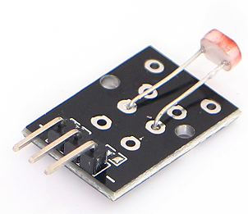

Main parameters and characteristics

1, according to the spectral characteristics of three photoresistor photoresistor: UV light-sensitive resistors, infrared light-sensitive resistors,

Visible photoresistor;

2, the main parameters are as follows:

A, dark current, the dark resistance: photoresistor at a certain applied voltage, when no light irradiation, when flowing

Current is called dark current. Applied voltage and the dark current ratio is called dark resistance;

B, Sensitivity: Sensitivity refers to the resistance value of the photoresistor from light irradiation (dark resistance) when irradiated with light and the

Resistance (light resistance) of the relative change value.

C, voltage characteristic curve. Volt-ampere characteristic curve used to describe the relationship between the applied voltage and the photoresistor photocurrent, of

The photosensitive device, its photocurrent increases with the applied voltage.

D, the temperature coefficient. Photoelectric effect photoresistor influenced by temperature, partial photoresistor optoelectronic at low temperatures

Higher sensitivity, whereas the sensitivity at high temperatures are lower.

E, rated power. Refers to the rated power for a certain line photoresistor allowed power consumed, when the temperature rise

High, its power consumption is reduced.

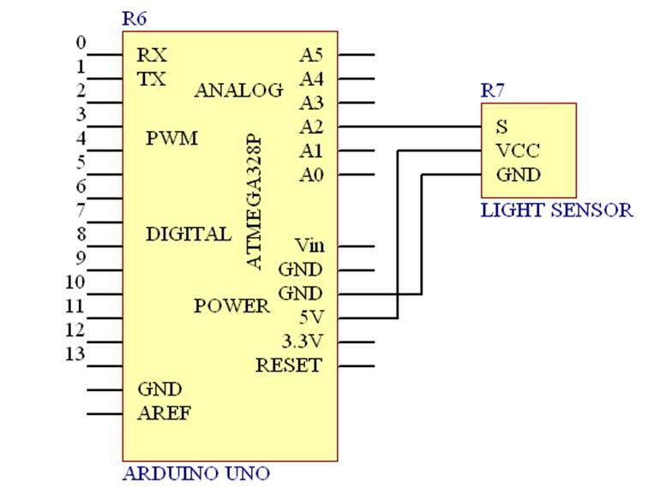

Test

1、Arduino UNO R3 × 1

2、USB Cable × 1

3、Module × 1

Test Code:

int sensorPin = 2;

int value = 0;

void setup() {

Serial.begin(9600);

}

void loop() {

value = analogRead(sensorPin);

Serial.println(value, DEC);

delay(50);

}

When have light and no light compare:

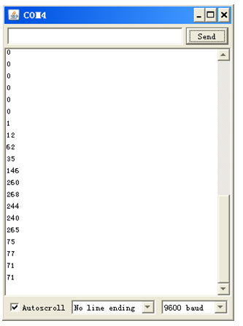

“0” is for no light,below is for having light value.